Windows Tuning Tips for Audio Processing

This guide covers important information on how to detect and resolve audio performance issues (crackling, drop outs, artifacts) on Windows systems during audio playback.

*Note: You can also view the*[*video version*](https://support.native-instruments.com/hc/articles/210264085)*of this article.*

<https://www.youtube.com/watch?feature=player_detailpage&v=BnbfVFqkKOA#t=187>

Disclaimer

This article mentions some third party tools which are not related to Native Instruments at all. Though we have successfully tested the mentioned tools in-house for a longer time, this and comparable tools can potentially damage your computer and harm the manufacturer's warranty of your computer and connected hardware. If you want to make sure that you do not act against the license agreements or other instructions given for the use of your computer, please contact the manufacturer of your computer or the developer of the third party tool directly.

Introduction

The list of brands for Windows computers, as well as the possible combination of hardware used in PCs is practically unlimited. This can lead to compatibility issues or undesired interaction of components. Additionally, many PC computers and their components are designed to deliver good performance for office applications or gaming. The demands placed on a computer used for music production are usually quite different than those for office or gaming computers. As a result, it will often be necessary to tune off-the-shelf or self-built computers into systems capable of processing audio data in real-time. This article provides the most important system tuning tips for real-time audio processing.

Please note that each of these tips may contribute to improving the overall performance of your system. Therefore, in case you are experiencing audio dropouts and artifacts, take the time to print out this article, read it carefully and try one suggestion after another.

Preliminary Settings

2.1. ASIO Drivers

Download and install the latest driver for your soundcard. If you use a Native Instruments audio interface, you will find the latest drivers [here](http://www.native-instruments.com/support/downloads/drivers-other-files/). In your audio application, make sure you always use of the **ASIO** driver for your soundcard, and not the DirectSound or WASAPI driver. If an ASIO driver is not available for your soundcard, you can download and install ASIO4ALL, a generic ASIO driver that works with most soundcards. You can download the latest ASIO4ALL driver from the website:

[http://www.ASIO4ALL.com](http://www.asio4all.com/)

*Note: Watch*[*this video*](https://support.native-instruments.com/hc/articles/209544809)*to learn how to configure ASIO4ALL for your on-board soundcard*

Please note that a professional audio interface which provides its own ASIO driver usually performs better than using ASIO4ALL with a generic audio interface. Typically, audio interfaces designed specifically for music recording and production have better audio quality, better performance and are equipped with ASIO drivers specific to the device. Native Instruments offers a number of professional interfaces with ASIO drivers designed for different purposes, such as KOMPLETE AUDIO 6 (music production) or TRAKTOR AUDIO 10 (DJ performance).

2.2. Latency Settings

Computers make use of an audio buffer in order to temporarily store audio data while the computer’s main processor switches between different tasks such as the graphical display, hard drive access, data exchange with connected peripherals such as MIDI controllers and, of course, audio processing. Because the system cannot process all of these tasks simultaneously, it needs to buffer data from the various processes. This is where the audio buffer (also named latency, process buffer, sample buffer) comes into play. The rule of thumb is, the faster the computer, the more calculations it can handle in a short amount of time and the smaller the audio buffer can be.

A smaller audio buffer is preferable because there is a direct relation between the audio buffer size and the resulting latency. The term [latency](https://support.native-instruments.com/hc/articles/209544629) describes the delay between performing an action (e.g. singing into a microphone) and reproducing the result (e.g. hearing your voice come back out of the speakers). The larger the buffer size, the larger the latency, and with it, the longer the delay between the execution of an audio event and hearing the result. This can be distracting when performing or recording.

The downside of using a smaller buffer size is that the smaller the buffer size / latency, the bigger the processing load on your computer. If your computer can’t handle all the work it is tasked with at the selected buffer size, you will experience pops and clicks or other artifacts in your audio output. This means that you will have to increase the audio buffer size so your computer can handle the workload.

Start out with an ASIO latency setting (buffer size) of 512 and verify if this gives you artifact-free results. If not, increase the buffer size by one increment at a time and try again. However, on some modern Multicore CPUs you may get better results with lower latency settings than with higher settings (e.g. audio performance problems may occur with 512, but not with 256 samples set as buffer). Therefore, test at least both settings 256 and 512.  Please consult the documentation of your audio interface to learn about its driver's latency settings.

Analyzing the Computer Performance

Identifying the causes of audio performance issues can be difficult. Fortunately you can perform tests to find out if any processes running on your computer are harming the audio performance, and to which degree your system is affected by them.

3.1. System Performance Test (NI Audio Interfaces Only)

The driver software (control panel) included with Native Instruments audio interfaces offers a test that helps you determine whether your system is experiencing audio performance problems. In some cases you will be able to completely resolve your performance issues simply by adjusting the settings in the control panel of your NI audio interface.

1. Make sure to have installed the latest Windows driver and firmware for your NI audio interface. You will find the latest drivers and device updaters [here](http://www.native-instruments.com/support/downloads/drivers-other-files/).
2. Make sure your audio interface is connected and that all applications are closed.
3. Launch the control panel for your audio interface from here: C: > Program Files > Native Instruments > *Your Device Name* Driver > **"*Your Device Name* Control Panel.exe"**.
4. Switch to the **Diagnostics**tab.  
   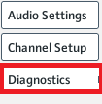
5. Click on the **Start**button of the**System Performance Test** to begin testing the performance of your system.  
   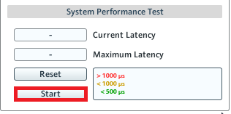

The System Performance Test will measure the current and maximum latency on your system and display them in the corresponding fields. As the coloring of the reference latency values (in microseconds or μs) indicates, measures above 1000 μs (1 milisecond) may lead to audio performance issues while values below 500 μs (half a milisecond) indicate a system that is capable of processing real-time audio data without any issues. The image below shows a running Performance Test where no critical audio problems have been detected. The maximum measured latency is **189 μs**, clearly below 500 μs. This means that the system is not showing any audio performance problems. Click **Stop**to finish the System Performance Test.  
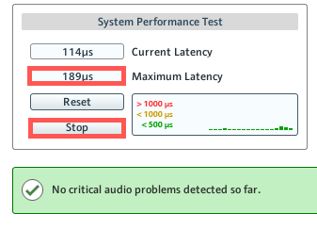

The image below shows a running Performance Test where audio problems have been detected. The maximum measured latency is **16110** **μs**, clearly above 1000 microseconds. The Performance Test is indicating performance issues on your system and their cause remains to be determined. Click on **Stop**to finish the System Performance Test.  
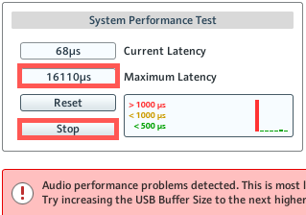

In case the System Performance Test detects audio performance problems, switch to the**Audio Settings** tab and verify the following settings under **Audio Processing** which may be causing the audio performance issues:

* **Sample Rate**: Make sure that it is set to **44100 Hz**. You may increase it to 48000. We do not recommend any higher settings unless your system is already optimized for real-time audio processing.  
  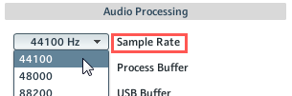
* **Process Buffer**: Set the value initally to **512 samples**. If you do not experience any audio crackling at this measure you may try lowering it to 256 samples.  
  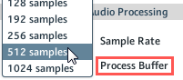
* **USB Buffer**: Set the value in relation to the Maximum Latency value measured by the System Performance Test (see above). For instance if the measured Maximum Latency is 1500 μs, set the USB buffer to **2 ms**. In the example we used above, the Maximum Latency value is higher than 16 miliseconds so that even adjusting the USB buffer value to its highest setting (4ms) will not be sufficient. This is a clear indicator that the latency issue cannot be resolved directly in the control panel.  
  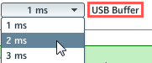

If adjusting the parameters in the control panel does not resolve your audio performance issues, you will need to determine the cause of the issue at a system level, as will be explained in the next section.

3.2. LatencyMon

The LatencyMon application can be used to identify which device, driver or service is causing the latency issue on your system.

1. Go to the Resplendence Software downloads page [here](http://www.resplendence.com/downloads).
2. Download the latest available LatencyMon version from the **System Monitoring Tools**section, then install the software.
3. Start LatencyMon. By default it is found here: C: > Program Files > LatencyMon > "LatMon.exe".
4. Launch the audio application you are experiencing latency issues with. If the audio problems occur in combination with an external audio interface, make sure the interface is connected and configured as audio device in the application.
5. Begin audio playback in the application. You can simply set a loop and let it play continuously.
6. While audio is playing in your application, launch the LatencyMon test by clicking on the green **Play**button.  
   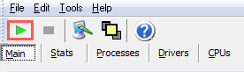

For LatencyMon to provide useful analysis results, the test must run for at least 4 minutes while audio is playing back in your audio application. This will ensure enough time for the audio artifacts to appear. Afterwards, stop the test by clicking on the **Stop**button next to **Play**.

After the test is finished, a text box under the **Main** tab will display either of these messages:

'Your system appears to be suitable for handling real-time audio and other tasks without dropouts.' (green text).

or

'Your system appears to be having trouble handling real-time audio and other tasks. You are likely to experience buffer underruns appearing as drop outs, clicks and pops...' (red text).

The former case indicates that your system should not present any latency issues. Should you experience performance issues in spite of the positive results of the LatencyMon test, verify the following:

* Check the settings in the control panel of your soundcard (latency, sample rate).
* Make sure that no other applications or services are running while operating your audio application.
* Update your audio interface to the latest driver and / or firmware version.
* Make sure that your system components meet our minimum system requirements.
* Verify if your processor's Speedstepping may be affecting your system performance (see chapter 3.2.2).

The latter case indicates that the latency issue needs to be resolved at a system level. The results of the LatencyMon analysis will provide help identifying the source of the issue, as will be explained in the next sections.

3.2.1. Identifying Problematic Drivers

After the LatencyMon test is finished, switch to the **Drivers** tab in order to obtain individual latency measurements for each of your system drivers. These values will be displayed in descending order in the **Highest execution (ms)** column. The image below shows no problematic drivers, since every value is significantly lower than 1 ms. 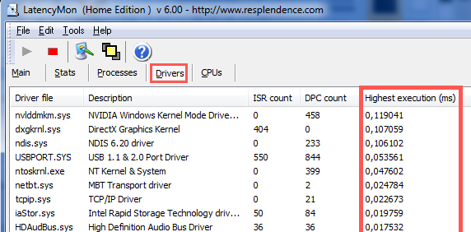

By comparison, the next image shows a driver reporting a latency value of **17,92 ms**. This value is clearly higher than 1ms and the driver associated with it (in this case **NVIDIA Windows Kernel Mode Driver**), needs to be deactivated , updated or reconfigured in order to reduce its latency values and ensure a problem-free audio performance.    
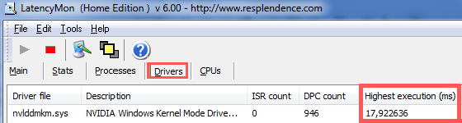

Please note that individual latencies of single drivers may add up to more than 1ms total latency (as an example, if two drivers are reporting 0.9 ms and 0.5 ms respectively, both values may add up to 1,4 ms which then can also create problems in the same way a driver with 1.4ms latency would).

If your drivers show latency values above 1 ms, check to which devices the affected driver belongs to, then disable the affected device in Windows Device Manager if possible. This is explained in chapter 4.1.

If you are unsure whether the device can be disabled without posing any harm to your system, search the web for the driver's name and/or the description of the device (as shown in the column **Description**of the LatencyMon Drivers overview) in order to find out if this device can be safely disabled.

We have compiled a list of drivers often reported to the Native Instruments support as causing high Highest Execution values in LatencyMon. This list, which contains hints on how to reduce the latency of these drivers, can be found as PDF document in the **Attachments**section at the bottom of this article.

3.2.2. Speedstepping

If the latency values of your system drivers are clearly below 1 ms but audio problems still occur, switch to the **Stats** tab of LatencyMon after having stopped the performance test. Under **CPU Speed** you will find two values: **Reported CPU Speed** and **Measured CPU Speed** (in MHz).   
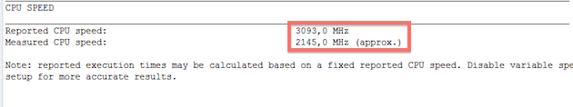

It is normal for the measured CPU speed value to be lower than the reported CPU speed value (as in the image above) since the reported CPU is only a theoretical measurement which is affected in practice by several factors (heat, amount of active cores, overall processor design, etc.). However, if no drivers are displaying high latency and the Measured CPU speed value is significantly lower than the Reported CPU speed value (as well as significantly lower than the CPU speed defined in our minimum system requirements), then the cause of the audio performance problems may be Speedstepping.

Speedstepping (or its equivalent for AMD called 'Cool'n'Quiet') is a technology implemented on some Intel processor models which allows for the CPU speed to decrease dynamically, helping save resources, reduce heat and extend battery life. However, this decrease of CPU clock may be detrimental for the stability of your audio data processing. To disable speedstepping, adjust the settings of your system's power plan, as explained in chapter 4.5.1.

*Note: If your audio problems persists after having adjusted your power plan and an additional LatencyMon test reveals no increase in the measured CPU speed, you may consider deactivating Speedstepping directly in the BIOS of your system. Additionally other technologies such as TurboBoost may be interfering with the stability of your CPU clock speed. Please seek advice from your system's manufacturer before performing any changes in the BIOS as they may potentially damage your system.*

Optimizing your System

4.1. Deactivate Devices in the Windows Device Manager

A common cause of audio dropouts are drivers or background services that are not related directly to audio processing. They task the CPU regularly and take up resources required to process audio data without interruptions.

LatencyMon should have given you an idea on which drivers or components on your computer may contribute to your audio performance problems – if necessary, you should have searched the internet to find out which of the file names LatencyMon listed as problematic belongs to which devices or drivers on your computer. With the list of names of potential problematic devices or drivers in front of you, start the Windows Device Manager:

* Windows 7: Right-click on the **Computer** icon on your Desktop and then select Properties > **Device Manager.**
* Windows 8: Move the mouse pointer towards the lower right corner of your Desktop and from the Charms Bar choose Search > **Settings**, then type "Device Manager". Click the Device Manager icon which appears to the left of the screen to open it.
* Windows 10: Go to to Start and type 'Device Manager'. Click on the search result to open the Device Manager.

Please be very careful not to disable devices whose functionality is essential for the operation of Windows. Below is a list of devices that you should never deactivate:

* System timer
* Keyboard
* System CMOS/real time clock
* Microsoft ACPI-Compliant System
* Numeric data processor
* Primary IDE Channel
* Secondary IDE Channel
* Graphics Controller
* Ultra ATA Storage Controllers

In general, you should not deactivate anything listed in the branch **System Devices**.

In the Device Manager, locate the device(s) LatencyMon reported as problematic. If this is a device that is not essential for the basic operation of your computer (see list above), right click on the component and choose **Deactivate** (not **Uninstall**!). Once you have disabled the problematic devices (according to LatencyMon), test if this has resolved the audio dropouts issue.

Additional devices that can often be disabled to further preserve system resources (or to test if saving additional resources helps resolve the problem), even if LatencyMon may not have listed them as problematic, are the following:

* Network adapter
* WLAN card
* Bluetooth port
* Infrared Port
* ACPI compliant battery
* Trackpad (only disable if a mouse is also connected)
* Video camera
* DVD drive
* Any third party component that is not an essential part of the system (be careful and only deactivate components you recognize and whose funcitonality is not vital for the normal operation of Windows)
* Built-in sound card (only if you are using an external sound card such as TRAKTOR AUDIO 6/10 or another USB sound interface from a third-party manufacturer)

4.2. Verify USB and Firewire Devices

For the purpose of identifying which device or driver may introduce the audio problem you are experiencing, disconnect or remove all USB or FireWire devices attached to your computer, except for your audio interface. Then test if the audio problems persist. If not, connect one device at a time and test again. If the problem re-appears after re-connecting a specific device, look for an updated driver or updated firmware for that device or contact its manufacturer.

If you use a bus-powered USB audio device, the device may not be receiving enough power from the USB port. Likewise, if several devices are connected to the same internal USB root hub (for instance via a self-powered USB hub), then the total demand of these devices may be consuming the shared available power. After ensuring that the problem has stopped when disconnecting all additional devices, connect one device at a time to the various USB ports on your computer and test if any of the ports works better.

4.3. BIOS Update

BIOS stands for Basic Input Output System, a boot-up routine that runs on a chip on your mainboard. The BIOS controls how the mainboard’s individual components work together (on a hardware management level, before Windows is launched). BIOS updates typically improve the performance of your mainboard’s components – mostly by fixing bugs. Just like with brand new software, updates for the BIOS are often released after new computers are sold, and resolve bugs or improve performance – sometimes dramatically.

If you have an off-the-shelf brand name computer (e.g. Dell, HP/Compaq, etc.) visit the manufacturer’s homepage and download and install the latest available BIOS update for your exact computer model. Instructions for this are usually posted on the website, or are included with the downloaded update. If you have a self-built computer, visit the mainboard manufacturer’s website to find the latest BIOS update. Running the latest BIOS version is very important if you need to get the best performance from your computer.

4.4. Chipset / Component Driver Update

Chipset refers to a group of important processor chips (aside from the computer’s main processor) on your computer’s mainboard, that are handling essential functions, such as hard drive and USB operation, etc. Some common chipset manufacturers are Intel, AMD and Nvidia. Windows is usually equipped with a set of built-in generic chipset drivers. However, these are often designed as a one-size-fits-all solution for the purpose of being compatible with as many different models as possible. The custom-tailored drivers provided by the chipset’s manufacturer often get much better performance than Windows’ built-in generic drivers.

If you have an off-the-shelf brand name computer (e.g. Dell, HP, Lenovo, etc.) visit the manufacturer’s homepage and download and install the latest available chipset drivers for your exact computer model. Installation instructions are usually posted on the computer manufacturer’s website, or are included with the downloaded update files. If you have a self-assembled computer, visit the mainboard manufacturer’s website to find the latest chipset drivers.

The same applies to all other hardware components installed in your computer: download and install all available driver updates for components such as network adapters, built-in audio interfaces, FireWire controllers, graphics drivers and any other devices or peripherals installed in, or attached to your computer. For brand name computers, these drivers can usually also be found on the computer manufacturer’s website. For self-built computers, you will need to visit the websites of the manufacturer of each hardware component and download and install their latest available drivers.

4.5. Energy Options

Modern computer systems, and especially mobile devices, are engineered for the purpose of saving as much energy as possible. However, this is often at the cost of the computer’s overall performance, making it more likely to experience audio dropouts. The following should be tried to eradicate energy-saving related performance problems.

4.5.1. Power Plan Settings

1. Open the Windows Control Panel
   * Windows 7: Go to Start > **Control Panel**
   * Windows 8: Move the mouse pointer towards the lower right corner of your Deskop and from the Charms Bar choose Settings > **Control Panel**
   * Windows 10: Go to to Start and type 'Control Panel'. Click on the search result to open the Control Panel.
2. In the Control Panel, choose System and Security > **Power Options**.
3. Set the Power Scheme to **High Performance** (if this setting is not available, click on **Show additional plans** first). Then click on **Change plan settings**.  
   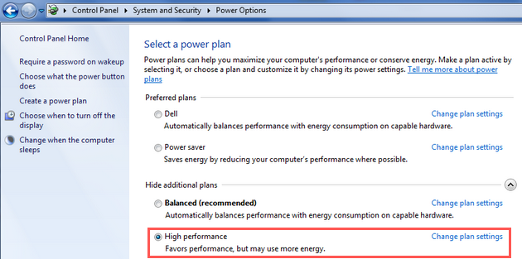
4. On the next page set both **Turn off the display** and **Put the computer to sleep** to **Never**.   
   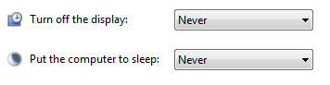
5. Then click **Change advanced power settings**. In the **Power Options** window make sure to adjust the following settings:

* Hard disc > Turn off hard disk after > Setting (Minutes) = **Never**
* Sleep > Sleep after > Setting (Minutes) = **Never**
* USB settings > USB selective suspend setting > Setting = **Disabled**
* Display > Turn off display after > Setting (Minutes) = **Never**
* Processor power management > Minimum processor state > Setting = **100%**
* Processor power management > Maximum processor state > Setting = **100%**

*Important Note: Many laptop manufacturers install a proprietary application that takes over the control of the energy settings of the CPU and other computer components. As a result the energy settings made in the Windows energy options do not become effective. Deactivate any such application and test if the settings described in this section then solve the performance issues you experience.*

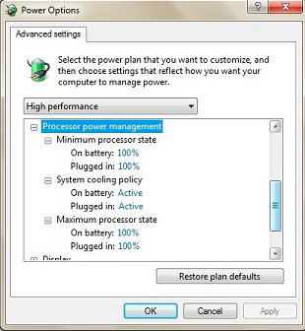

4.5.2. USB Ports Power Settings

1. Open the Windows Device Manager
   * Windows 7: Right-click on the **Computer** icon on your Desktop and then selecting Properties > **Device Manager.**
   * Windows 8: Move the mouse pointer towards the lower right corner of your Desktop and from the Charms Bar choose Search > **Settings**, then type "Device Manager". Click the Device Manager icon which appears to the left of the screen to open it.
   * Windows 10: Go to to Start and type 'Device Manager'. Click on the search result to open the Device Manager.
2. In the **Universal Serial Bus controllers** section, right-click each **USB Root Hub**, choose **Properties.**  
   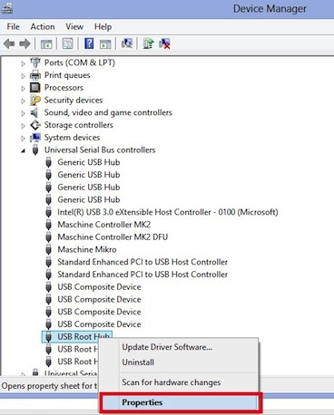
3. In the **Power Management** tab of the **USB Root Hub Properties** window, untick the **Allow the computer to turn off this device to save power** option.  
   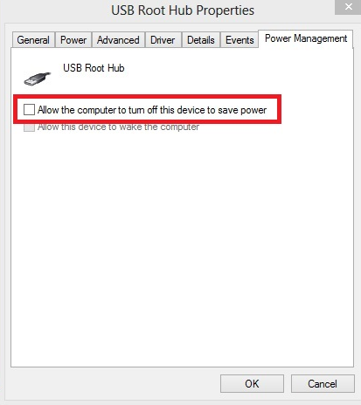

4.6 Graphic Card Tools

Some graphic card tools like Ati Power Play and Nvidia Powermizer may interfere with real-time audio since they prioritize the graphic card performance at the expense of other system processes. Try to disable or uninstall these tools.

With some Nvidia laptop graphic chips, simply deactivating the graphic drivers in the Windows device manager can occasionally help to fix audio dropout problems. When you deactivate the graphic driver in the Device Manager, a standard Windows video driver will be activated after the next system reboot. This should help identify if the graphic driver may be a possible cause of the problem.

4.7. Processor Scheduling

The **Processor scheduling** setting lets you choose if your computer should process **Programs** with higher priority, or **Background Services** with higher priority. In this context, **Programs** refers to applications you can see and interact with on your screen. **Background Services**refers to software that you don't directly interface with, but is running in the background and handling essential system tasks. The most important example of a background service in the context of this guide is the driver for your audio interface.

A common reason for dropouts and audio artifacts is the audio interface driver not being able to process all of its data in time. Increasing the processing priority for background services (and with it, the priority of the audio driver) often contributes to an improved audio performance. To configure your computer to process background services with higher priority, do the following:

1. Open the Windows Advanced System Settings.
   * Windows 7: Right-click the **Computer** icon on your desktop. Then select Properties > **Advanced System Settings**
   * Windows 8: Move the mouse pointer towards the lower right corner of your Deskop and from the Charms Bar choose Settings > Control Panel. Then open the System menu and click on **Advanced System Settings**.
   * Windows 10: Right-click on the **This PC** icon on any Explorer window and select Properties > **Advanced System Settings**.
2. On the **Advanced** tab under **Performance** click the **Settings...** button.
3. Once again, on the **Advanced** tab under **Performance Options** select **Background  services**.

*Note:that some applications may work better if the Processor Scheduling parameter remains set to Programs. If your audio performance worsens after following the steps above, revert the setting back to****Programs****. You may also refer to the documentation of the manufacturer of the software for more information on what setting should be used.*

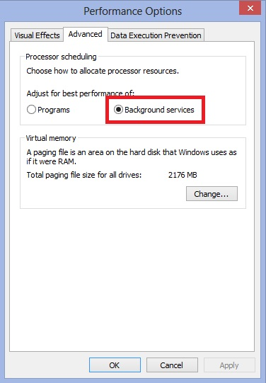

 4.8. Hard Drive Options

The configuration of your hard drive described below will allow it to work more efficiently when you record and play back audio files:

1. Open the Properties of the hard drive (or drives) you use to store your audio files.
   * Windows 7: Go to Start >**Computer**
   * Windows 8: Move the mouse pointer towards the lower right corner of your Deskop and from the Charms Bar choose **Search**, then type 'Explorer'. Click the Explorer icon that appears to the left of the screen to open it.
   * Windows 10: Open any Explorer folder and click on **This PC**.
2. Right-click on the drive(s) you intend to use for audio storage.
3. Choose **Properties**.
4. Make sure to untick both **Compress this drive to save disk space** and **Allow files on this drive to have contents indexed**.'
5. Click **Apply** and then **OK**.

